02nd August 2018

**YOKOHAMA’s GEOLANDAR M/T G003 Supporting Ikuo Hanawa in Asia Cross Country Rally**

YOKOHAMA announced on 6th July that it will support the team led by Ikuo Hanawa in the “Asia Cross Country Rally 2018” (hereafter AXCR), Asia’s largest cross-country rally, which will start on 12th August. The Company’s support will include supplying the “GEOLANDAR M/T G003” mud terrain tyres from its GEOLANDAR SUV tyre brand.   
  
The AXCR is an FIA (Federation Internationale de l’Automobile) officially sanction race, similar to the Dakar Rally. The AXCR has been held in August every year since the first race in 1996. Over the years, the race’s course has taken competitors across mountains, jungles, beaches, and even race car circuits in several Southeast Asian countries. YOKOHAMA was an official sponsor for 11 straight years, from 2001, and machines running on its “GEOLANDAR” tyres finished second and third in 2011 and second in 2012. This year’s rally will start on 12th August at Pattaya in Thailand, and racers will cover approximately 2,200km before finishing in Phnom Penh, Cambodia, on 18th August.  
  
Ikuo Hanawa is a world-class off-road racer representing Japan. He has a long and distinguished record. He captured 10 consecutive championships in Japan’s ultimate off-road race competition, the JFWDA Championship Race Series. In 1991, Mr. Hanawa became the first Japanese to finish the Baja 1000, one of the world’s biggest off-road racing events, and in 2002 he captured a class championship in that same race. YOKOHAMA has partnered with Mr. Hanawa in many races, including the Baja 1000. In April this year, Mr. Hanawa rode YOKOHAMA’s “GEOLANDAR M/T G003” tyres to victory in the APL SMOKIN’ WHEELS 2018 off-road endurance race held in Guam.   
  
The “GEOLANDAR M/T G003” is a mud terrain tyre marketed by YOKOHAMA in August 2017. In addition to delivering superior performance on all off-road conditions, from mud to rock, dirt and gravel, the “GEOLANDAR M/T G003” has achieved a superior tread life. In addition, the tyre features an impressively aggressive design and provides a quiet comfortable ride on city streets. The “GEOLANDAR M/T G003” was a recipient of Japan’s Good Design Award in 2017.

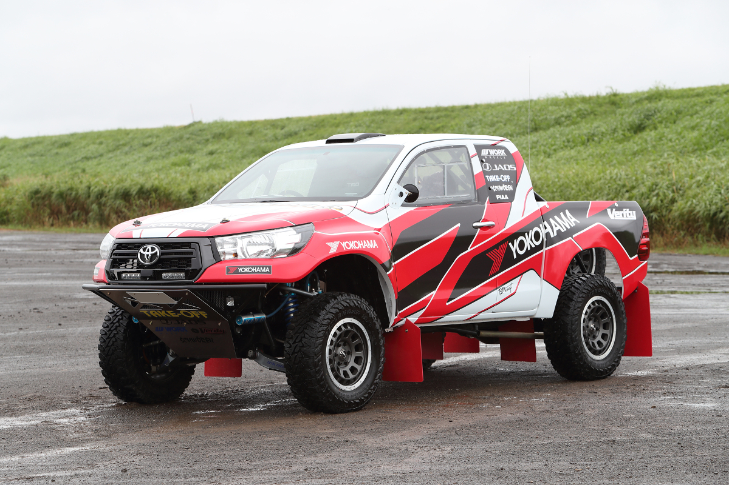

*HILUX REVO off-road racing machine*

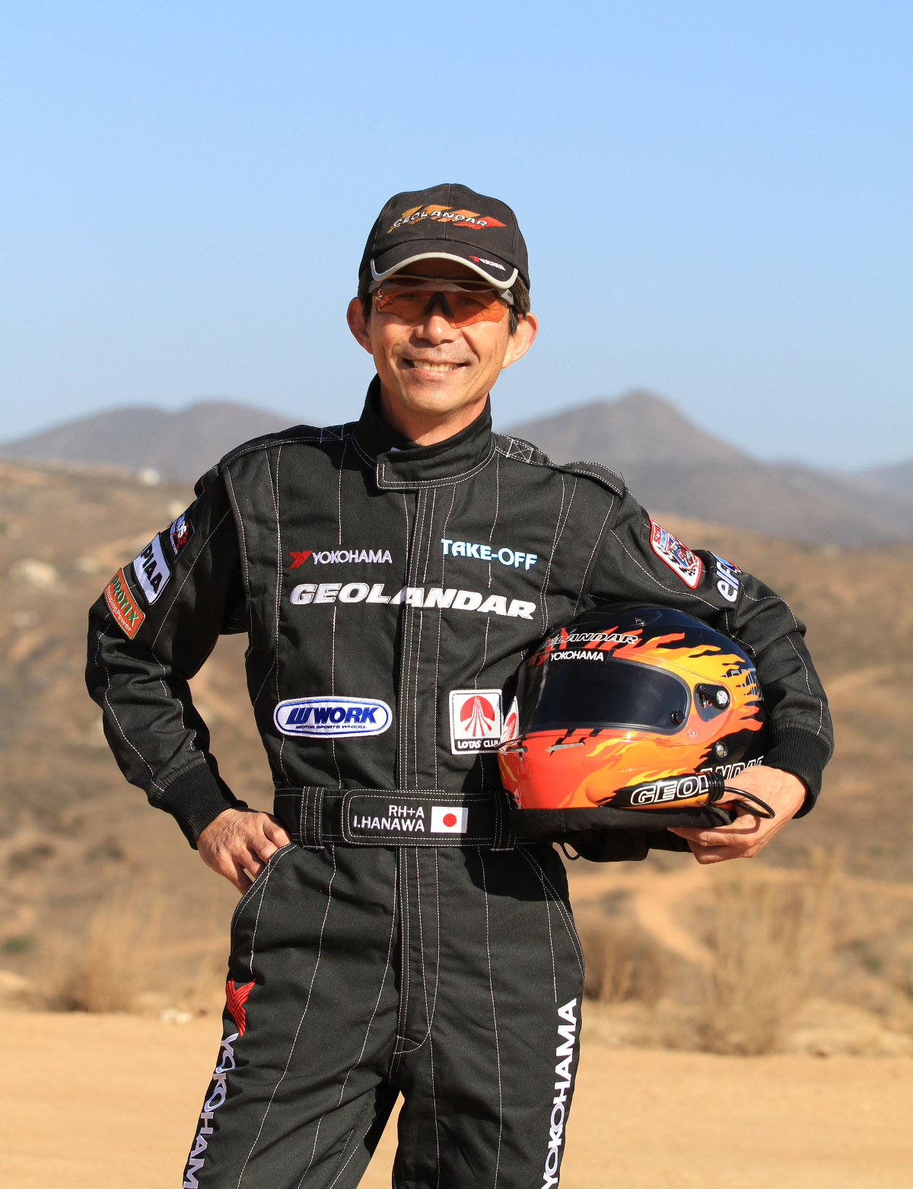

*Ikuo Hanawa*